Lab Week 3

# Purpose: To gain an understanding of the following:

* System Sequence Diagrams
* Events
* Domain Models
* Operation Contracts

# Instructions: Answer the following questions and Bring solution to lab next week.

Q1. Prepare a system sequence diagram for use case *“`professor submits grades”*

(Specification created in Lab 2)

Q2. Consider an Event table for a library system . Make appropriate assumptions to limit the scope of the system. Focus on events related to the circulation of books. Ignore the acquisition and disposal of lendable items.

Q3.

1. Draw a Domain model for the use case Check out Library book shown in figures below

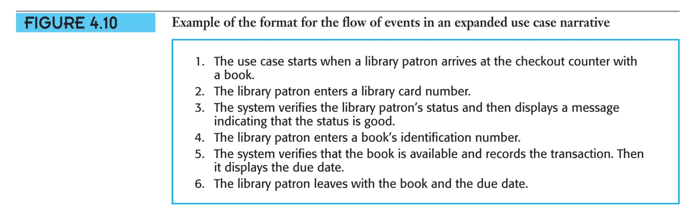

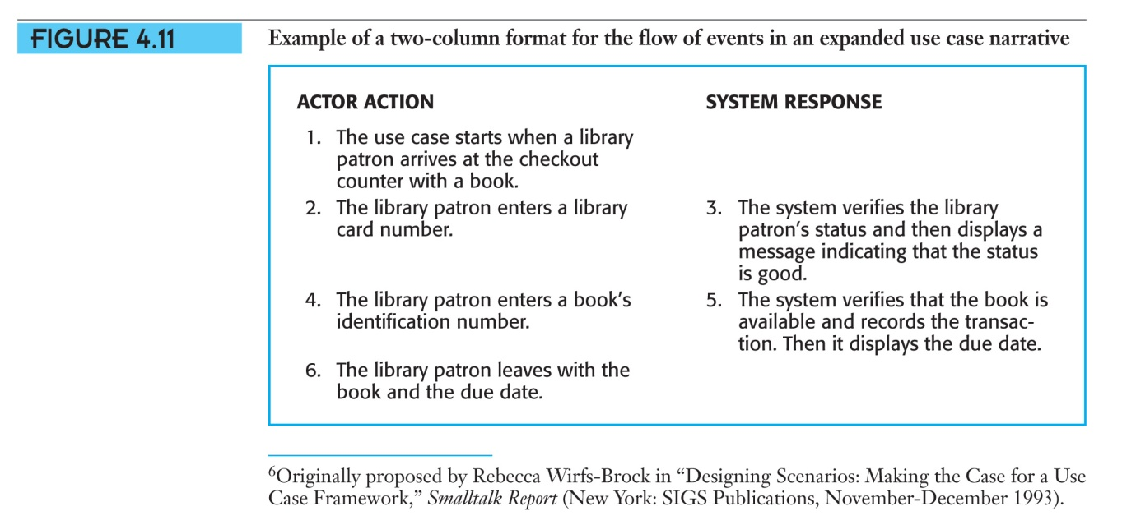

Q4 Modify the domain model Figure 5.23. for the Public University Registration System to accommodate the new events identified in lab 2

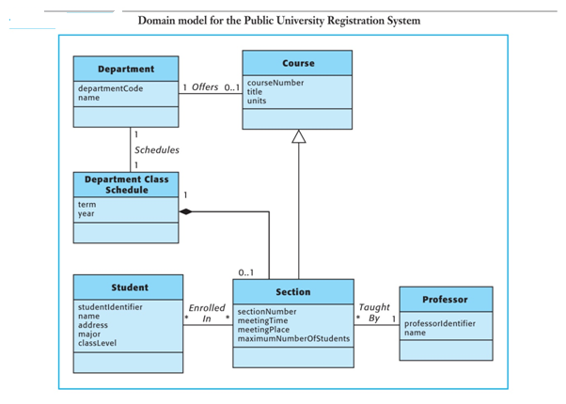

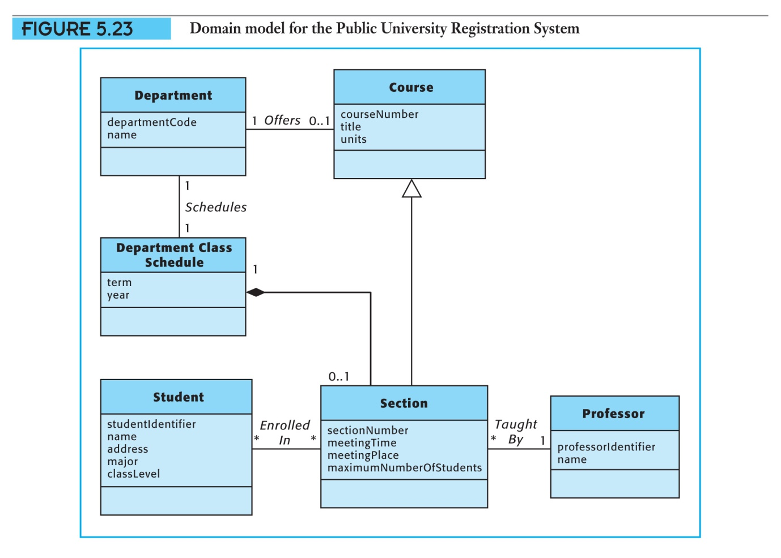

Q5 Write a system operation contract for each of the operations shown in your system sequence diagram below

